React Object Practice Work

EXERCISE 1 :

var mydata = [{"states":["GUJARAT","RAJASTHAN",{"PORTION":"WEST INDIA"},{"LANGUAGES":["GUJARATI","MARWADI",["HINDI","ENGLISH"]]}]},

{"CODES":{"GUJARAT":"GJ","RAJASTHAN":"RJ"}},["7.07 CR","8.5 CR"]];

1. PRINT TOTAL NUMBER OF MAIN KEYS
2. PRINT NAME OF ALL MAIN KEYS
3. PRINT GJ
4. PRINT GUJARAT
5. PRINT MARWADI
6. PRINT ENGLISH
7. PRINT WEST INDIA
8. PRINT 7.07 CR

EXERCISE 2 :

var result = {

"students":["RAVI","NAYAN","RAJ","KISHAN"],

"subjects":["MATHS","ENGLISH","SCIENCE"],

"maths_marks":[55,75,28,95],

"english_marks": [88,78,99,91],

"science_marks":[72,68,54,66]

}

PRINT ABOVE OBJECT DATA IN TABLE AS SHOWN BELOW :

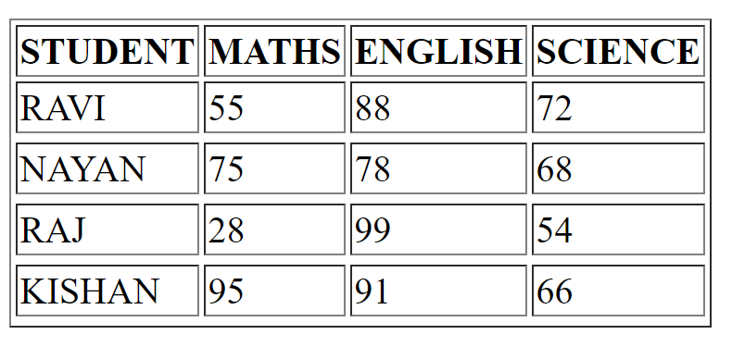

AFTER COMPLETING ABOVE TABLE TRY TO PRINT MARKS < 35 IN RED FONT ( AS STUDENT IS FAIL IN THAT SUBJECT )

EXERCISE 3 :

DATA TAKEN FROM BITCOIN LIVE API

API URL : <https://api.coindesk.com/v1/bpi/currentprice.json>

var mydata = {"time":{"updated":"Jan 30, 2024 21:17:27 UTC","updatedISO":"2024-01-30T21:17:27+00:00","updateduk":"Jan 30, 2024 at 21:17 GMT"},"disclaimer":"This data was produced from the CoinDesk Bitcoin Price Index (USD). Non-USD currency data converted using hourly conversion rate from openexchangerates.org","chartName":"Bitcoin","bpi":{"USD":{"code":"USD","symbol":"&#36;","rate":"43,645.996","description":"United States Dollar","rate_float":43645.996},"GBP":{"code":"GBP","symbol":"&pound;","rate":"34,377.943","description":"British Pound Sterling","rate_float":34377.9433},"EUR":{"code":"EUR","symbol":"&euro;","rate":"40,241.085","description":"Euro","rate_float":40241.0846}}};

SOLVE FOLLOWING :

1. PRINT TOTAL NUMBER OF MAIN KEYS
2. PRINT NAME OF ALL MAIN KEYS
3. PRINT BITCOIN PRICE IN USD ( IN ABOVE DATA ANSWER WILL BE 43,645.996 )

EXERCISE 4 :

COPY DATA FROM BELOW API LINK AND PASTE IN A VARIABLE mydata = _ _ _ _ _ ;

( add semicolon at the end of variable data )

API URL : <https://api.coindesk.com/v1/bpi/currentprice.json>

Print table as shown below :







